Level 1
Task 3 Project Structure

Android Studio has two different Project Structures: -
• Android
• Project
🧭 Structure 1: Android View (Logical Structure)
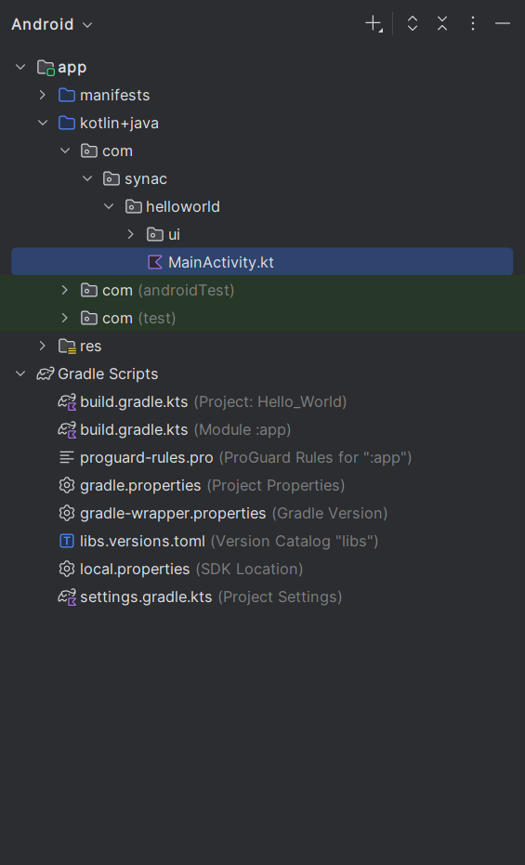
This view organizes the project based on Android development conventions, making it easier to navigate components relevant to app development.
🔹 Key Sections:
- app module
  - manifests: Contains AndroidManifest.xml, which declares app components, permissions, and metadata.
  - java/kotlin:
    - com.synac.helloworld.ui: Holds your main Kotlin file MainActivity.kt.
    - com (androidTest): For instrumentation tests that run on Android devices.
    - com (test): For unit tests that run on the JVM.
  - res: Contains resources like layouts, drawables, strings, etc. (not expanded in the image).
- Gradle Scripts
  - build.gradle.kts (Project & Module): Kotlin DSL files for build configuration.
  - proguard-rules.pro: Rules for code shrinking and obfuscation.
  - gradle.properties, local.properties: Project and SDK settings.
  - libs.versions.toml: Centralized version catalog for dependencies.
  - settings.gradle.kts: Declares modules and project settings.
✅ Purpose:
This view is developer-friendly, focusing on logical groupings like UI, tests, and resources. It hides irrelevant files and folders, helping you focus on app components.

🗂 Structure 2: Project View (Physical File System)
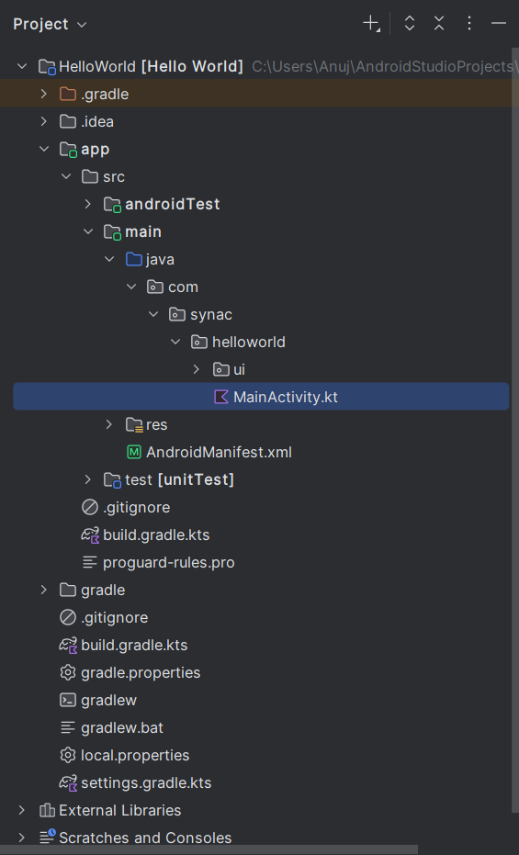
This view shows the actual file structure on disk, reflecting how files are stored in your system.
🔹 Key Sections:
- Root Directory: C:\Users\Anuj\AndroidStudioProjects\HelloWorld
- Subdirectories:
  - .gradle, .idea: IDE and build system metadata.
  - app/src/main/java/com.synac.helloworld.ui: Contains MainActivity.kt.
  - app/src/main/res: Resources like XML layouts, images, etc.
  - app/src/androidTest, app/src/test: Instrumentation and unit test folders.
  - gradle: Contains wrapper files (gradlew, gradlew.bat, etc.).
  - build.gradle.kts, settings.gradle.kts, local.properties: Build and environment config files.
✅ Purpose:
This view is file-system accurate, useful for version control (Git), debugging file issues, or understanding how Android Studio organizes files behind the scenes.

